**DAILY ONLINE ACTIVITIES SUMMARY**

|  |  |  |  |  |
| --- | --- | --- | --- | --- |
| **Date:** | 07/07/2020 | **Name:** | JASLINE SHARON TAURO | |
| **Sem & Sec** | 4th sem,  A Section | **USN:** | 4AL18CS029 | |
| **Online Test Summary** | | | | |
| **Subject** | N/A | | | |
| **Max. Marks** | N/A | **Score** | N/A | |
| **Certification Course Summary** | | | | |
| **Course** | Lightning Experience Customization | | | |
| **Certificate Provider** | salesforce | **Duration:** | | 3 hrs |
| **Coding Challenges** | | | | |
| **Problem Statement:**   Write a java program to find ASCII code of a character. | | | | |
| **Status:** | |  | | |
| **Uploaded the report in GitHub** | | YES | | |
| **If yes Repository name** | | <https://github.com/jaslinesharontauro/JAVA_Prgms> | | |
| **Uploaded the report in slack** | | YES | | |

**Certification Course Details:**

Today I continued the course “Lightning Experience Customization” by salesforce. Today I learnt about Custom object highlights, details and compact layouts. And also learnt how to create and edit custom buttons and links. Today I have successfully completed this course and have received two badges for the same.

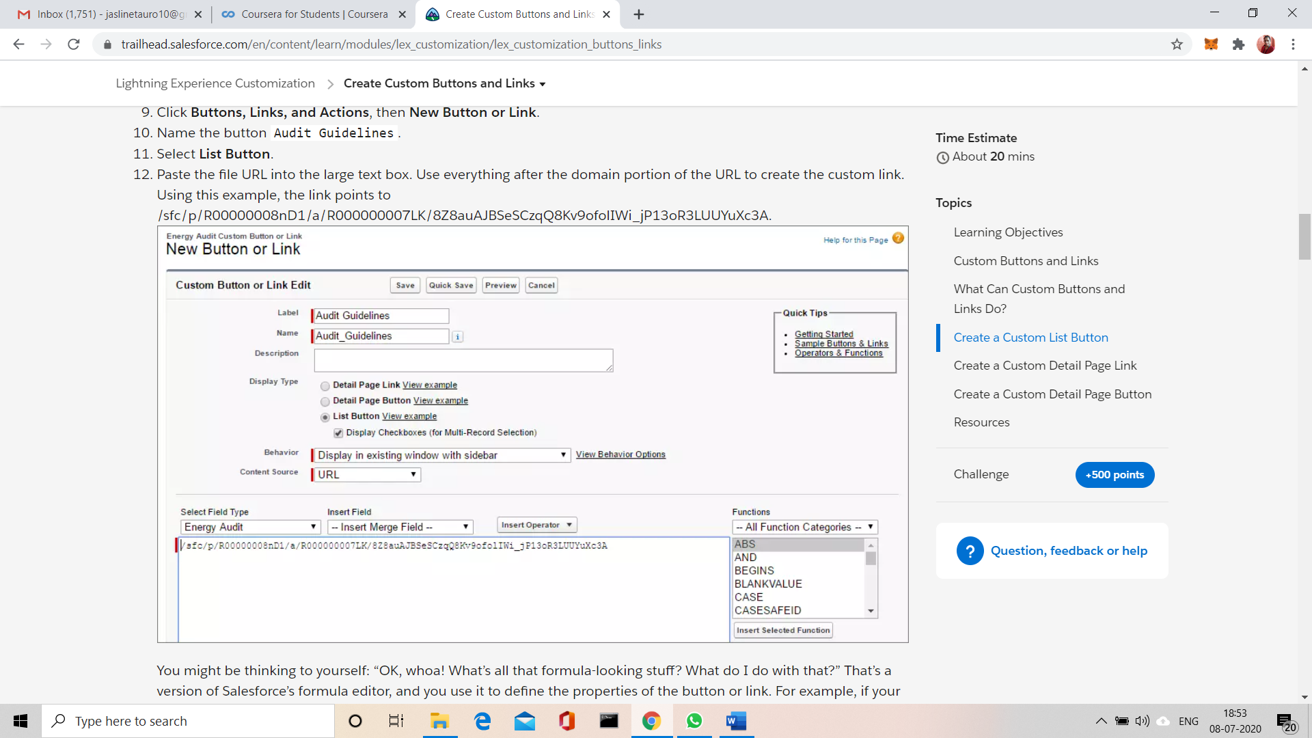

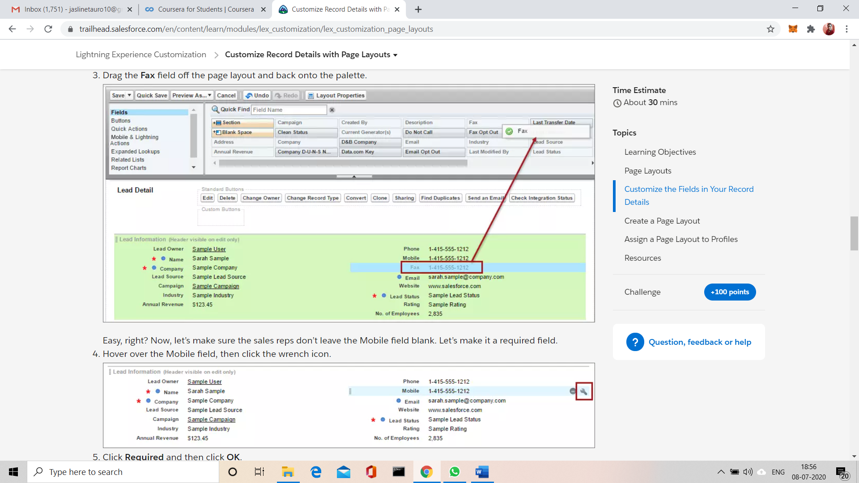

 

CODING CHALLENGES:

Problem Statement:

## Write a java program to find ASCII code of a character.

Output:

ASCII value of P is: 80

ASCII value of P is: 80

Solution uploaded in GitHub

